# JS Fundamentals: Test Exam

*This is a test exam for course* [*JavaScript Fundamentals*](https://softuni.bg/courses/javascript-fundamentals) *at SoftUni.*

## Problem 2. Crossword

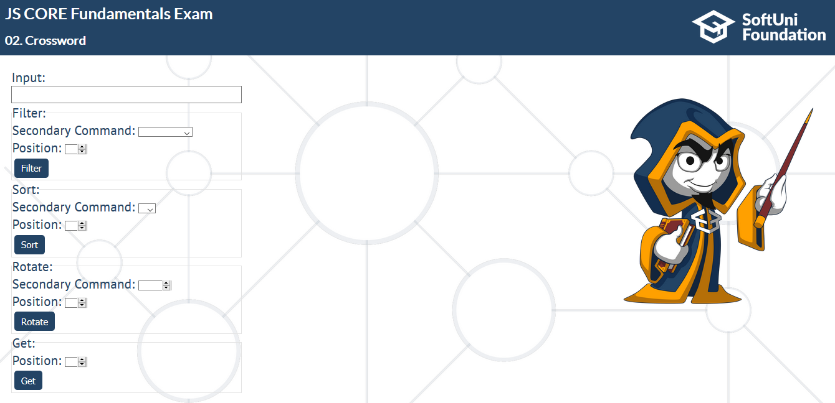

You will receive a **string** into **Input field.** After that one of the main commands properties will be filled with certain information.

Here are all the possible commands and secondary commands:

* **filter**
  + **UPPERCASE** – filter all the uppercase letters then take the character at the given position
  + **LOWERCASE** – filter all the lowercase letters then take the character at the given position
  + **NUMS** – filter all the digits and take the digit at the given position
* **sort**
  + **A** – sort all the characters alphabetically and then take the character at the given position
  + **Z** – sort all the characters alphabetically in descending order and take the character at the given position
* **rotate**
  + The secondary command will be a number representing how many times to rotate the string (rotation means that the last element becomes first) – when it’s done, take the character at the given position
* **get**
  + Just get the character at the given position (in this case there is no secondary command)

**NOTE: consider the position as a position, not an index**

When a **button** from a main command **fieldeset** is **clicked**, the result from that command must be **appended** to the paragraph into div element with **id** "**output**".

### Example

|  |  |
| --- | --- |
| **Input** | **Output** |
| Input string: **AkIoRpSwOzFdT** Main command: **Filter** -> **UPPERCASE** **4**  --  Input string: **AOB**  Main command: **Sort** -> **A** **3**  --  Input string: **FAILCL**  **Main command: Sort** -> **A 3**  --  Input string: **OUTAGN**  Main command: **Sort** -> **Z 2**  **--**  Input string: **01S345U7N**  Main command: **Filter** -> **UPPERCASE 2**  **--**  Input string: **DAN**  Main command: **Rotate** -> **2 2**  **--**  Input string: **PING**  Main command: **Get** -> **2**  **--**  Input string: **?- 654**  Main command: **Get** -> **3** | **"SOFTUNI "** |

